Friends of Poly-Western
Annual Golf Tournament

I am contacting you to request your support and sponsorship for the 13th Annual Friends of Poly-Western Golf Tournament that will be held at The Greystone Golf Club on Thursday, May 23rd, 2024. The tournament will include golf, an awards banquet and events to raise funds to support Baltimore Polytechnic Institute and Western High School.

The Friends of Poly-Western established the Gerald Perrin Memorial Scholarship and the Robin Kane-Prater Scholarship to recognize graduating seniors from Baltimore Polytechnic Institute (Poly) and Western High School. Funds raised from the tournament will be used to provide scholarships to deserving graduates from Poly and Western who share a passion for academic excellence, commitment to support Poly and Western, and commitment to community service.

We hope you will be able to support this event as a golfer or a sponsor or both. Your participation and tax-deductible donation will help us provide this critical financial assistance and support for the outstanding students at these historic and high performing high schools in Baltimore City.

Friends of Poly-Western (FOPW) is a recognized Non-Profit 501(C) 3 organization that was established in 2004 to serve the young ladies and gentlemen of two of the highest excelling public schools in Maryland. Poly and Western High School have produced high achieving and highly productive students for over 100 years. The goal of FOPW is to be supportive of the needs of both schools, through fundraising, scholarships and community involvement.

If you have any questions or need additional information, please contact Carl Jackson at (410)746-4606 or Arthur Grier at (443)220-6988.

Respectfully Yours,
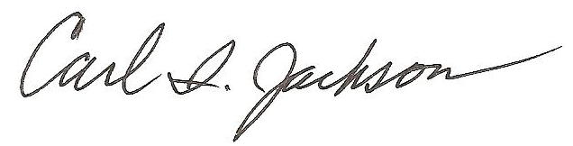
Carl I. Jackson
President, Friends of Poly-Western

Friends of Poly-Western Tax Exempt ID 51-0589845

PO Box 32085, Baltimore, MD 21282-2085

friendsofpolywestern@gmail.com Facebook: Friends of Poly / Western (F.O.P.W.)

www.friendsofpolywestern.com

Donation Details

- Double Eagle Sponsor - $2,500 or more
  - Special Recognition at the awards banquet
  - Advertisement Banner at the awards banquet
  - Recognition on the the FOPW website
  - Foursome included
  - Option to present Sponsor Check Replica at the awards banquet
- Eagle Sponsor - $2,000
  - Recognition at the awards banquet
  - Advertisement Placard at the Hole-In-One Contest Hole
  - Foursome included
  - Recognition on the FOPW website
  - Option to present Team trophies and Contest Prizes at the awards banquet
- Birdie Sponsor - $1,500
  - Recognition at the awards banquet
  - Advertisement Placard at the Closest-to the-Pin Contest Hole
  - Recognition on the FOPW website
  - Option to present Team trophies and Contest Prizes at the awards banquet
- Gold - $1,000
  - Advertisement Placard at Longest Drive Contest Hole
  - Option to present Team trophies and Contest trophies at the awards banquet
  - Recognition on FOPW website
  - Recognition at the awards banquet
- Silver - $500
  - Advertisement Placard at any non-contest hole
  - Recognition on the FOPW website
  - Recognition at the awards banquet
- Bronze - $100 or less
  - Recognition on the FOPW website
  - Recognition at the awards banquet

